Project/Programme Title: | _____________________________
Country/Region: | _____________________________
Accredited Entity: | _____________________________
National Designated Authority: | _____________________________
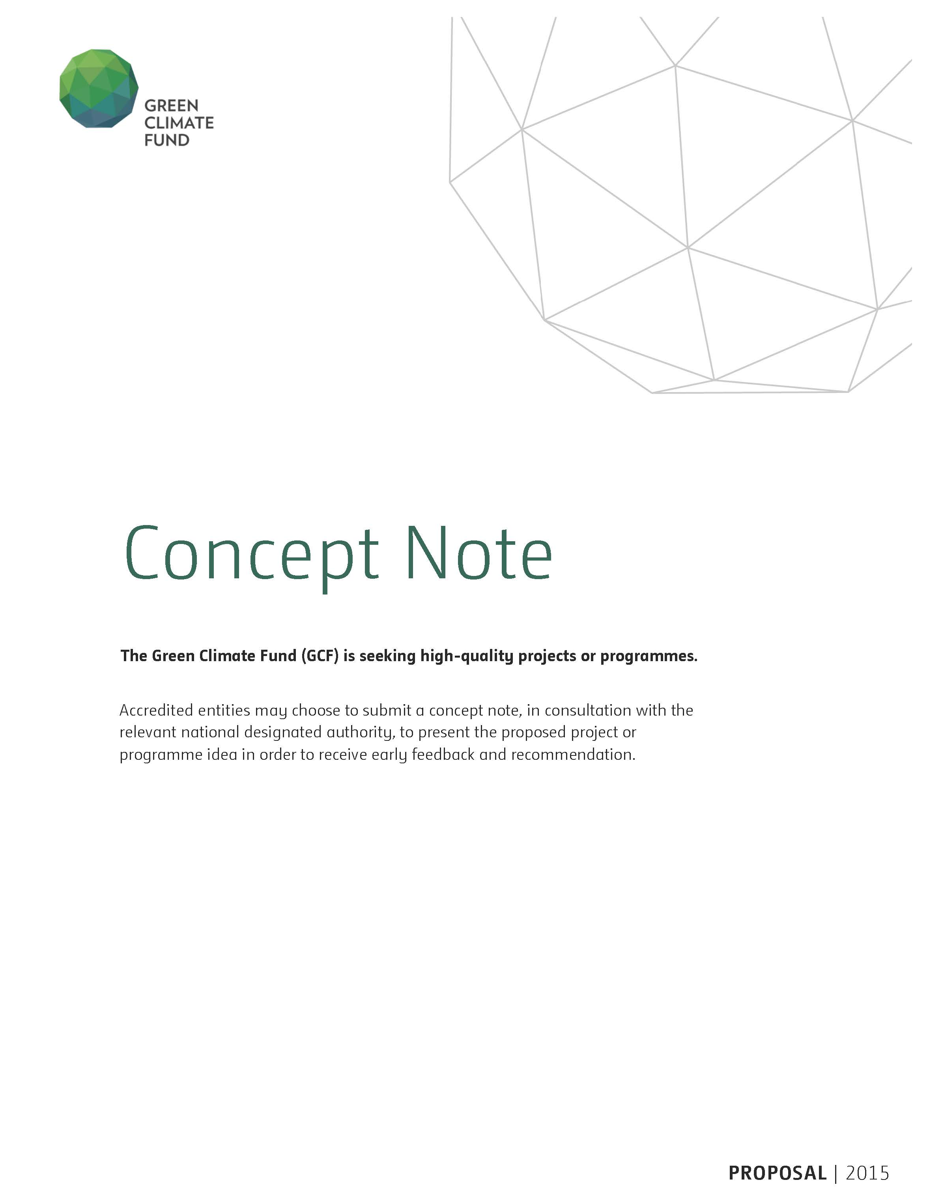
Please submit the completed form to fundingproposal@gcfund.org
A. Project / Programme Information
A.1. Project / programme title
A.2. Project or programme | Choose an item.
A.3. Country (ies) / region
A.4. National designated authority(ies)
A.5. Accredited entity
A.6. Executing entity / beneficiary | Executing Entity:  Beneficiary:
A.7. Access modality | Direct ☐ International ☐
A.8. Project size category (total investment, million USD) | Micro (≤10) ☐ Small (10<x≤50) ☐ Medium (50<x≤250) ☐ Large (>250) ☐
A.9. Mitigation / adaptation focus | Mitigation ☐ Adaptation ☐ Cross-cutting ☐
A.10. Public or private | Choose an item.
A.11. Results areas  (mark all that apply) | Which of the following targeted results areas does the proposed project/programme address?
Reduced emissions from:
☐ Energy access and power generation
(E.g. on-grid, micro-grid or off-grid solar, wind, geothermal, etc.)
☐ Low emission transport
(E.g. high-speed rail, rapid bus system, etc.)
☐ Buildings, cities, industries and appliances
(E.g. new and retrofitted energy-efficient buildings, energy-efficient equipment for companies and supply chain management, etc.)
☐ Forestry and land use
(E.g. forest conservation and management, agroforestry, agricultural irrigation, water treatment and management, etc.)
Increased resilience of:
☐ Most vulnerable people and communities
(E.g. mitigation of operational risk associated with climate change – diversification of supply sources and supply chain management, relocation of manufacturing facilities and warehouses, etc.)
☐ Health and well-being, and food and water security
(E.g. climate-resilient crops, efficient irrigation systems, etc.)
☐ Infrastructure and built environment
(E.g. sea walls, resilient road networks, etc.)
☐ Ecosystems and ecosystem services
(E.g. ecosystem conservation and management, ecotourism, etc.)
A.12. Project / programme life span | …………… years
A.13. Estimated implementation start and end date | Start: ………………………...  End: ………………………….

B. Project/Programme Details
The Fund requires the following preliminary information in order to promptly assess the eligibility of project/programme investment. These requirements may vary depending on the nature of the project/programme.
B.1. Project / programme description (including objectives)
B.2. Background information on project/programme sponsor | Describe project/programme sponsor’s operating experience in the host country or other developing countries.  Describe financial status and how the project/programme sponsor will support the project/programme in terms of equity, management, operations, production and marketing.
B.3. Market overview | Describe the market for the product(s) or services including the historical data and forecasts.  Provide the key competitors with market shares and customer base (if applicable).  Provide pricing structures, price controls, subsidies available and government involvement (if any).
B.4. Regulation, taxation and insurance | Provide details of government licenses, or permits required for implementing and operating the project/programme, the issuing authority, and the date of issue or expected date of issue.  Describe applicable taxes and foreign exchange regulations.  Provide details on insurance policies related to project/programme.
B.5. Implementation arrangements | Describe construction and supervision methodology with key contractual agreements.  Describe operational arrangements with key contractual agreements following the completion of construction.  Provide a timetable showing major scheduled achievements and completion for each of the major components of the project/programme.

C. Financing / Cost Information
C.1. Description of financial elements of the project / programme |  | Please provide:  - a breakdown of cost estimates analysed according to major cost categories.  - a financial model that includes projection covering the period from financial closing through final maturity of the proposed GCF financing with detailed assumptions and rationale;  - a description of how the choice of financial instrument(s) will overcome barriers and achieve project objectives, and leverage public and/or private finance.
C.2. Project financing information |  | Financial Instrument | Amount | Currency | Tenor | Pricing
 | Total project financing  (a) = (b) + (c) |  | ………………… | Options
 | (b) Requested GCF amount | (i) Senior Loans  (ii) Subordinated Loans  (iii) Equity  (iv) Guarantees  (v) Reimbursable grants *  (vi) Grants * | …………………  …………………  …………………  …………………  …………………  ………………… | Options  Options  Options  Options  Options  Options | ( ) years  ( ) years | ( ) %  ( ) %  ( ) % IRR
 |  | * Please provide detailed economic and financial justification in the case of grants.
 |  | Total Requested  (i+ii+iii+iv+v+vi) | ………………… | Options
 | (c) Co-financing | Financial Instrument | Amount | Currency | Name of Institution | Seniority
 |  | Options  Options  Options  Options | …………………  …………………  …………………  ………………… | Options  Options  Options  Options | …………………  …………………  …………………  ………………… | Options  Options  Options  Options
 |  | Lead financing institution: ………………………
 | (d) Covenants
 | (e) Conditions precedent to disbursement

D. Expected Performance against Investment Criteria
Please explain the potential of the Project/Programme to achieve the Fund’s six investment criteria as listed below.
D.1. Climate impact potential  [Potential to achieve the GCF's objectives and results] | Specify the climate mitigation and/or adaptation impact. Provide specific values for the below indicators and any other relevant indicators and values, including those from the Fund’s Performance Measurement Frameworks.  - Total tonnes of CO₂ eq to be avoided or reduced per annum  - Expected total number of direct and indirect beneficiaries and number of beneficiaries relative to total population (e.g. total lives to be saved from disruption due to climate-related disasters)
D.2. Paradigm shift potential  [Potential to catalyze impact beyond a one-off project or programme investment] | Provide the estimates and details of the below and specify other relevant factors.  - Potential for scaling-up and replication (e.g. multiples of initial impact size)  - Potential for knowledge and learning  - Contribution to the creation of an enabling environment  - Contribution to the regulatory framework and policies
D.3. Sustainable development potential  [Potential to provide wider development co-benefits] | Provide the estimates of economic, social and environmental co-benefits. Examples include the following:  - Economic co-benefits  - Total number of jobs created  - Amount of foreign currency savings  - Amount of government’s budget deficits reduced  - Social co-benefits  - Improved access to education  - Improved regulation or cultural preservation  - Improved health and safety  - Environmental co-benefits  - Improved air quality  - Improved soil quality  - Improved biodiversity  - Gender-sensitive development impact  - Proportion of men and women in jobs created
D.4. Needs of recipient  [Vulnerability to climate change and financing needs of the recipients] | Describe the scale and intensity of vulnerability of the country and beneficiary groups and elaborate how the project/programme addresses the issues. Examples of the issues include the following:  - Level of exposure to climate risks for beneficiary country and groups  - Does the country have a fiscal or balance of payment gap that prevents from addressing the needs?  - Does the local capital market lack depth or history?  - Needs for strengthening institutions and implementation capacity
D.5. Country ownership  [Beneficiary country ownership of project or programme and capacity to implement the proposed activities] | Provide details of the below and specify other relevant factors.  - Coherence and alignment with the country’s national climate strategy and priorities in mitigation or adaptation  - Brief description of executing entities (e.g. local developers, partners and service providers) along with the roles they will play  - Stakeholder engagement process and feedback received from civil society organizations and other relevant stakeholders
D.6. Effectiveness and efficiency  [Economic and financial soundness and effectiveness of the proposed activities] | Provide details of the below and specify other relevant factors (i.e. debt service coverage ratio), if available.  - Estimated cost per t CO2 eq (total investment cost/expected lifetime emission reductions)  - Co-financing ratio (total amount of the Fund’s investment as percentage of project)  - Economic and financial rate of return  - With the Fund’s support  - Without the Fund’s support

E. Brief Rationale for GCF Involvement and Exit Strategy
Please specify why the GCF contribution is critical for the project/programme.

Please explain how the project/programme sustainability will be ensured in the long run, after the project/programme is implemented with support from the GCF and other sources.

F. Risk Analysis
Please describe the financial and operational risks and discuss mitigating measures.

Please briefly specify the substantial environmental and social risks that the project/programme may face and the proposed risk mitigating measures.

G. Multi-Stakeholder Engagement
Please specify the plan for multi-stakeholder engagement, and what has been done so far in this regard.

H. Status of Project/Programme
- A pre-feasibility study is expected to be completed at this stage. Please provide the report in section J.

- Please indicate whether a feasibility study and/or environmental and social impact assessment has been conducted for the proposed project/programme: Yes ☐ No ☐
(If ‘Yes’, please provide them in section J.)

- Will the proposed project/programme be developed as an extension of a previous project (e.g. subsequent phase), or based on a previous project/programme (e.g. scale up or replication)? Yes ☐ No ☐
(If yes, please provide an evaluation report of the previous project in section J, if available.)

I. Remarks

J. Supporting Documents for Concept Note
☐ Map indicating the location of the project/programme
☐ Financial Model
☐ Pre-feasibility Study
☐ Feasibility Study (if applicable)
☐ Environmental and Social Impact Assessment (if applicable)
☐ Evaluation Report (if applicable)

Please use the following naming convention for the file name: “[CN]-[Agency short name]-[Date]-[Serial number]” (e.g. CN-ABC-20150101-1).

